## Facilitator agenda

### Session goals

1. Begin thinking about how heat and green space impacts us and our communities
2. Begin making connections between heat/green space and topics
3. Break into teams

### Agenda

| **Time** | **Duration** | **Facilitator** | **Activity** | **Materials** | **Notes** |
| --- | --- | --- | --- | --- | --- |
| 9:25-9:35 | 10 mins | AT | **Icebreaker**   * Describe a perfect summer day   + What do you see   + How do you feel? * What are your favorite outdoor spaces?   + Do a combined map?   Alt:   * Close your eyes and imagine you are outdoors and it is perfect - what do you see? * Now imagine being outside of Sayre - what do you see? * Icebreaker for intro to new students joining * Take as many pieces of chocolate/candy as you want but don’t eat them yet | Chocolate/ colored candy  Slide with prompt (see left) | * Form 3 small groups with grad students and youth ~ 6-8 pax * Each group will do this activity within their group * 1-2 minutes per person * No sharing out to the class   Pivot: If someone took many pieces of candy - you can stop after 5 things they found joyful to give time for others to share. |
| 9:35-9:45 | 10 mins | AT | **Check in**   * Briefly summarize what we covered last week for new students joining for the first time & our goal for the semester * Circle back/activity that links back to YPARC activity/check out from session 1 * Check in about taking photos in the classroom - what’s the purpose?   + To document collaboration products/ideas in the moment (show an example from last week), the process & activities we did together, how we intend to use them at the end of the semester.   + Thumbs up/down about being in photos and we will not do so for those students (Repeat each week if there are new students joining?) | * Slides with the synthesized definitions * Show the group the transcribed words/phrases from last week + synthesized definition |  |
| 9:45-10:05 | 20 mins | EF | **Climate brainstorm**   * Sticky note activity to brainstorm some positive and negative impacts of heat and green space on the community * Instructions [2 minutes] * Brainstorm – [5 minutes each station]   + When it’s hot out, how does that impact how you feel, and what you can do – at home, school, and other places in our community? Are some people you know more impacted than others?   + Are there places you have used to cool down, where are they?   + How does having trees, parks and other green spaces impact how you feel, and what you can do in our community? Are some people you know more impacted than others?   + Does having access to green space affect the temperature that you feel?   + Write ideas and then dot vote + new idea contribution * Debrief [5 mins]   + In groups, collectively summarize the themes for each question | * Sticky notes with prepared prompts * **Flip charts - one for each prompt on each corner of the class** * Pens | * Alternate activity since this is similar to what we did last time: gallery walk - timed, silent walk around the classroom, individuals add sticky notes * Do this activity in a combined version of the groups we were in last time (merge Ben and Kirsten’s groups) |
| 10:05-10:12 | 7 mins | DC | **Break into topic teams + grab a snack / stretch break**   * Remind everyone of the topics that students have identified / share topic groupings * Break into teams for the rest of the session | * **Slide on the topic groupings from students** * Paper/sticky notes * Pens | * Assign groups by students interest   Pivot: If students don’t have a group or some groups are too big - reassign to be more evenly distributed? |
| 10:12-10:25 | 13 mins | EF/AT/DC (in groups) | **Topic think/pair/share**   * Prompts   + What was your favorite greenspace/ recap initial activity   + What do we all have in common?   + Why did you choose this topic?   + What do you already know about this topic from your research in the fall?   + What do you want to know more about?   + Is there a connection that comes to mind when you think of this topic and heat or green space? * Think [2 mins] * Pair [3 mins] * Share with topic team [8 mins] | * Paper/sticky notes * Pens | * Print out prompts for the “Share” so students can prepare to share out |
| 10:25-10:45 | 20 mins | EF/AT/DC (in groups) | **Topic–climate connections**   * [10 mins] Provide statements describing connections between topics and heat / green space and ask students to respond to each statement (e.g. from literature)   + Here’s some of what scientists know about the connection between this topic and heat/green space   + How do you feel about hearing this? Does it match/differ from your experience? How does this affect you? * [10 mins] Building from the texts, brainstorm ways that the topic might be affected by heat and green space   + 2x2 grid on flip chat with heat, green space, positive and negative   + Based on what we just learned and your own experience/knowledge, answer the following questions:   + How might heat positively affect the topic issue?   + How might heat negatively affect the topic issue?   + How might green space positively affect the topic issue?   + How might green space negatively affect the topic issue?   + Place sticky notes for ideas in each quadrant * [5 mins] Upvote connections and discuss themes as a team; this will be a jumping off point for next week | * **Print or write connection text on flipcharts - 2x2 grid** * **Slide with the prompts to put up in front of class** * Sticky notes * Print out statements/news headlines/ social media posts so students can read them | * Provide a lay-facing summary rather than verbatim quotes - avoid jargon * e.g. “In places that have higher extreme temperatures, scientists found that X also tends to be more common” or “People who experience extreme heat were more likely to report Y” |
| 10:45-10:55 | 10 mins | EF/AT/DC (in groups) | **Check out & feedback**   * Team circle * Share out one thing you learned today and one thing you’re curious to know more about next time we meet | * Pass out sticky notes if students want to write them down instead of sharing out aloud |  |

## Topic–climate connections prep instructions

Each topic team identifies 1-2 lay statements for heat and 1-2 lay statements for green space associations from our readings in Week 2 or other sources (could be a summary of results from local studies, local news headlines, press releases, social media posts, others) and writes them below, including the source. We’ll print these out and use them for the topic-climate connection activity.

Some examples

* <https://www.gc.cuny.edu/news/how-volatile-temperatures-shape-violent-crime>
* <https://www.kptv.com/2024/07/08/portland-sees-spike-gun-violence-heat-wave-blankets-metro-area/>
* <https://abcnews.go.com/Health/extreme-heat-impact-mental-health-high-temperatures-sweep/story?id=111984255>
* <https://www.usatoday.com/story/news/nation/2024/06/20/extreme-heat-wave-mental-health/74154600007/>
* <https://www.instagram.com/hopelinkbh/p/C8UfSXFAH1P/?locale=fr&hl=bg&img_index=1>
* [https://www.instagram.com/unhabitat/p/DFGGezxpACI](https://www.instagram.com/unhabitat/p/DFGGezxpACI/)
* <https://www.urbanhealthlab.org/urban-nature>

## **Gun violence group statements (Tyasia, Kirsten)**

1. **Heat and violence:**

* Across studies, “increased temperature had a significantly positive relationship with violent crime, assault, and homicide across differ- ent study regions, time periods, and temperature ranges.” (Choi et al)
* While this varies across climates globally and across cities in the U.S., there is overall evidence of a positive relationship between “short-term increased temperature exposure and the crime or violence risk”
* Less is known about long-term exposure to heat
* “As maximum daily temperature deviates from the expected, there was an association with increased shooting incidents” (Bushover et al., 2024) – *in Chicago, New York City, Cincinnati, and Philadelphia*
* Competing theories on the association between heat and shootings.
  + Temp aggression theory: increases in violence in areas that are already hot.
  + Routine activity theory: change in ambient temperature alters people's routine activities.
    - Warmer temps, more people outside, more opportunities for crime & violence.

1. **Heat in Philadelphia:**

* *Note: see points from Brooke/Ben/Daniel’s group on* ***the relationship between built environment and neighborhood heat***

1. **Green space and crime/safety:**

* findings from Garvin et al., 2013:
* A study in Philadelphia found that greening vacant spaces led to a “decrease in the number of total crimes and gun assaults around greened vacant lots compared with control.”
* Importantly, “People around the intervention vacant lots reported feeling significantly safer after greening compared with those living around control vacant lots (p<0.01).”
* Other findings from a meta-analysis (Hunter et al., 2019):
* “One study, conducted over 10 years, using a difference-in-difference design found statistically significant reductions in gun assaults and vandalism, while residents reported decreased stress and greater physical activity (Branas et al., 2011).”
* “The third study found a significant reduction in heart rate in African-Americans exposed to greened compared to non-greened vacant lots (South et al., 2015). “
* “Finally, the South African study reported significant improvements in biodiversity in range of greening interventions in three deprived urban areas (Anderson et al., 2014).”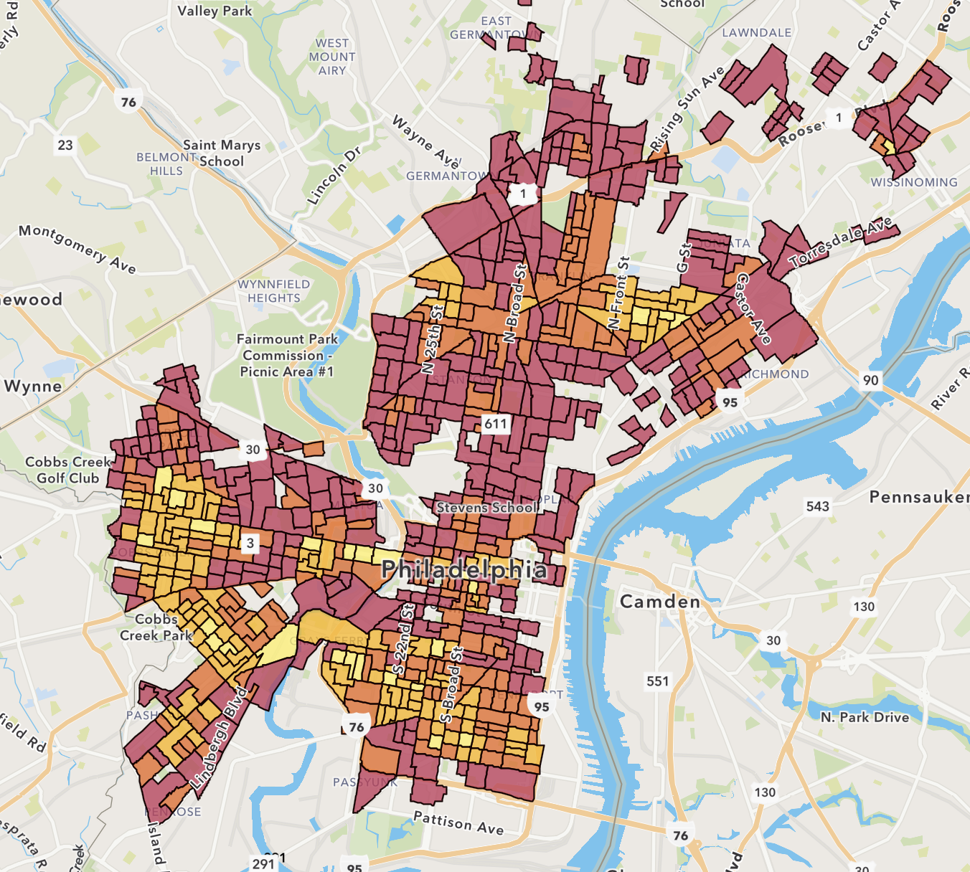

1. **Green space and heat:**

* Green spaces, particularly with trees, are important sources of shade which significantly reduce area temperatures to reduce the severity of high heat. <https://sustainablecitycode.org/brief/creating-green-zones/>
* “Areas with more concrete, roads, parking lots, and fewer trees trap heat, making them hotter on average.” The Nature Conservancy (<https://storymaps.arcgis.com/stories/1a131b1d4dd74143a47ae556809c72b3>)

## **Mental health group statements (Kate, Anicca)**

* “Greening vacant urban land significantly reduces feelings of depression and improves overall mental health for the surrounding residents” ([Penn Medicine](https://www.pennmedicine.org/news/news-releases/2018/july/greening-vacant-lots-reduces-feelings-of-depression-in-city-dwellers-penn-study-finds)).
* “Extreme weather events, like hurricanes and floods, can cause psychological distress and trauma. Rising temperatures can lead to increased rates of anxiety, depression, and suicide” ([Wellcome.org](https://wellcome.org/news/explained-how-climate-change-affects-mental-health)).
* “Post-traumatic stress disorder, depression, anxiety and other mental health problems arecommon at the time of extreme weather events and can persist for months, even years afterwards, especially if people are exposed tomultiple events. This can increase the likelihood of using substances as a way to cope” ([The Conversation](https://theconversation.com/5-reasons-why-climate-change-may-see-more-of-us-turn-to-alcohol-and-other-drugs-217894)).

## 

## Under-resourcing group statements (Brooke, Ben, Daniel)

**Heat + Under-resourcing**

1. **The built environment affects how hot a neighborhood is.** Many of the hottest areas in Philadelphia (North, West, and South) are also the ones with fewer trees/vegetation, more pavement, black rooftops, and older buildings that trap heat ([WHYY](https://whyy.org/articles/philadelphia-built-environment-temperature-increase-12-degrees/), [City of Philadelphia](https://www.phila.gov/2019-07-16-heat-vulnerability-index-highlights-city-hot-spots/), [The Nature Conservancy](https://www.nature.org/en-us/newsroom/philadelphia-urban-heat-map/)).
   1. “Some parts of Philadelphia can be as many as 22°F hotter than other neighborhoods” ([City of Philadelphia](https://www.phila.gov/2019-07-16-heat-vulnerability-index-highlights-city-hot-spots/)).
   2. “In areas with the highest need for trees, temperatures soared as much as 10.5 degrees higher in some areas than others at the same time of day in July; the max temperature recorded was 95 degrees” ([The Nature Conservancy](https://www.nature.org/en-us/newsroom/philadelphia-urban-heat-map/)).
2. **Vulnerable communities face the greatest heat risks.** People in under-resourced neighborhoods, especially older adults and those with health conditions, are more likely to live in homes that get dangerously hot in the summer, increasing the risk of heat-related illness ([Uejio et al, 2011](https://www.sciencedirect.com/science/article/pii/S1353829210001838)).
   1. “Groups that are historically vulnerable to extreme heat include elderly (age >= 60) females and people with pre-existing health problems such as obesity, cardiovascular disease, and diabetes (Mirchandani et al., 1996). Victims of extreme heat tended to live upstairs, in brick row homes, without a cooling device, and extremely hot indoor temperatures (> 54ºC)” ([Uejio et al, 2011](https://www.sciencedirect.com/science/article/pii/S1353829210001838)).

**Green Spaces + Under-resourcing**

1. **Green spaces support community well-being.** Parks and tree-lined streets do more than cool down neighborhoods—they create gathering spaces, strengthen social ties, and improve mental health. But these benefits are often missing in under-resourced areas.
   1. “The dimensions of social health of individuals based on urban green space could be divided into four groups: social contacts, social relations, social support and social connections, which were mainly affected by the physical characteristics, perceptions, and usages of urban green space to varying degrees” ([Huang & Lin, 2023](https://www.sciencedirect.com/science/article/pii/S1618866723001401)).
   2. “Studies investigating the causal mechanisms underlying green spaces and human health find that green spaces 1) increase physical activity, 2) foster social contacts, 3) reduce stress and restore attention, 4) enhance immune function, and 5) improve air quality” ([McIntire et al., 2022](https://www.sciencedirect.com/science/article/pii/S1618866722003338)).
2. **Access to parks and trees isn’t equal.** Some neighborhoods have lots of green space, while others have very little. This means that lower-income communities miss out on natural cooling, clean air, and the social benefits that parks provide ([The Nature Conservancy](https://www.nature.org/en-us/newsroom/philadelphia-urban-heat-map/), [Trust for Public Land](https://www.tpl.org/city/philadelphia-pennsylvania)).
   1. “In Philadelphia, residents in low-income neighborhoods have access to 21% less park space per person than those in the average Philadelphia neighborhood and 45% less than those in high-income neighborhoods” ([Trust for Public Land](https://www.tpl.org/city/philadelphia-pennsylvania)).